Baha’i Month 3 May 5th, 2026 Baha’i’s of Tonga
. . . . . . . . . . . . . . . . . . . . . . . . . . . . . . . . . . . . . . . . . . . . . . . . . . . . . . . . . . . . . . . . . . . . . . . . . . . . . . . . . . . . . . . . . . . . . . . . . . . . . . . . . . . . . . . . . . . . . . . . . . . . . . . . . . . . . . . . . . . . . . . . . . . . . . . . . . . . . . . . . . . . . . . . . . . . . . . . . . . . . . . . . . . . . . . . . . . . . . . . . . . . . . . . . . . . . . . . . .
The Monthly Bugle

"Blessed are they who follow the Light in their youthful days..."
Editorial Board:
Youth

. . . . . . . . . . . . . . . . . . . . . . . . . . . . . . . . . . . . . . . . . . . . . . . . . . . . . . . . . . . . . . . . . . . . . . . . . . . . . . . . . . . . . . . . . . . . . . . . . . . . . . . . . . . . . . . . . . . . . . . . . . . . . . . . . . . . . . . . . . . . . . . . . . . . . . . . . . . . . . . . . . . . . . . . . . . . . . . . . . . . . . . . . . . . . . . . . . . . . . . . . . . . . . . . . . . . . . . . . .

Have You Heard The Latest Good News?

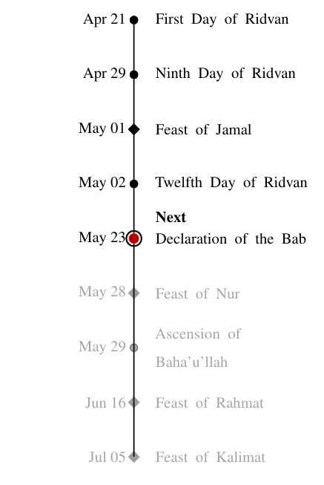
Feasts & Holy Days Timeline

Figure 1: Upcoming Baha’i Feasts and Holy Days
R
idvan, the most sacred Baha’i festival, commemorates
the period in 1863 when Baha’u’llah declared His mission as a Manifestation of God. Celebrated over 12 days, Baha’is around the world gather for prayer, re- flection, and community events with observances on the 1st, 9th, and 12th days. This festival also includes the election of Local and National Spiritual Assemblies, held in a spirit of joy, unity, and devotion.

Unit Convention
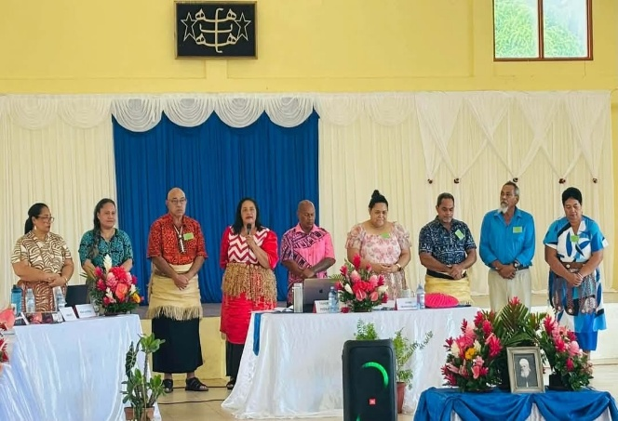
Figure 2: Newly elected NSA members 2026

Over the course of 3 days, Baha’is
gathered to reflect on community affairs, reflect on messages and guidance from the Universal House of Justice (UHJ), and ultimately, appointing 9 new members of the National Spiritual Assembly (NSA). The members are:
- ‘Etita Tonga
- Tahirih Hokafonu
- Sione Taumoefolau
- Tupou Nonu
- Pedroniume Pani
- Sarah Tu’uta
- Paea Tukuafu
- Owen Muller
- Meleane Mahe

Feast of Jamal / Ridvan

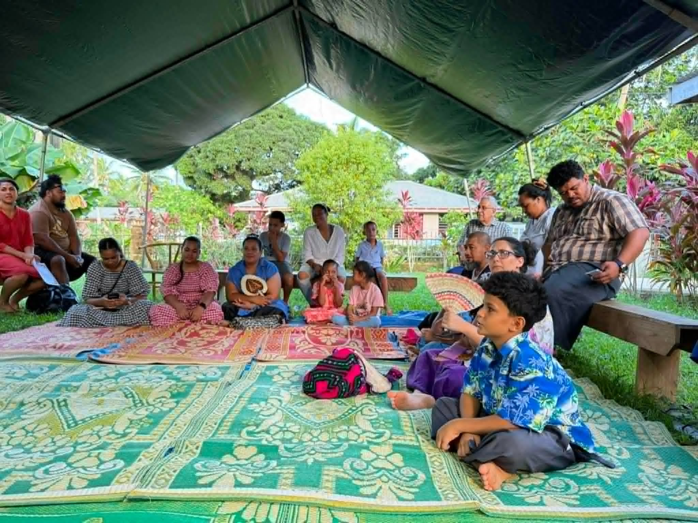

Figure 3: Feast at Tofoa
Tofoa community observed both the 9th Day of Ridvan and the feast of Jamal – joined by friends from ‘Eua and Brisbane.

Many commended the hard work, vibrancy, and spirit of the youth during the Convention, with one person sharing that the Youth brings hope to their hearts and serves as a model for the youth within their own cluster. The community was also able to envision their goals for BE183. Children’s classes, JY’s, Youths and Adults to voice out their general goals for the first year of this next phase. Camps and women’s committee were suggested to start and the Youth to finish Ruhi Book 1-7 by next Year.
The LSA members elected for this year are:
-Mercy Kafalava
-Saba Payman
-‘Ona Kafalava
-Ma’ata Bahbahani
-Keleni Katoa
-Blakely Kafalava
-Losaline Pongi
-Mafoa Kafalava
-Ella Kafalava

Zumba at 6am
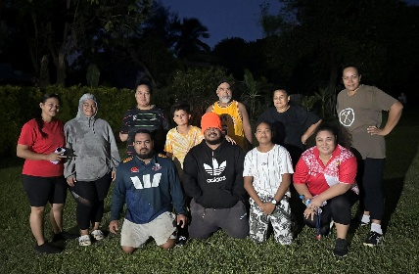

Figure 4: Morning Excercise

As of May 4th, morning Zumba sessions will run every Monday and Wednesday from 6:00-6:30am - promoting healthy and active lifestyles within the community. These will take place at the Pongi residence – open to all friends and family to join for laughs and Zumba!

Gate to Glory and Greatness
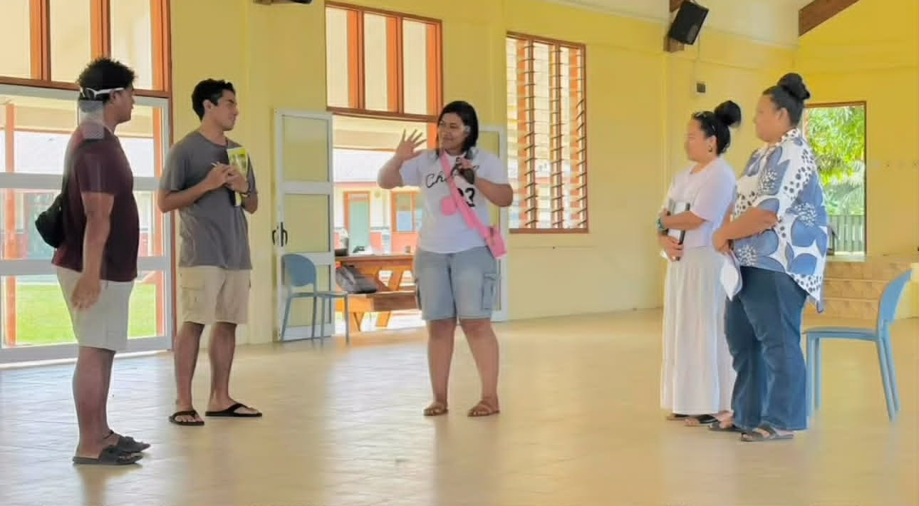

Figure 5: Sharing a prayer

A nation-wide camp was conducted over 5 days, devoted to a focused study of Book 7 (’Walking a Path of Ser vice’) with the intention to strengthen the

capacity of the friends in tutoring Book 1. Core principles nurtured the creating spaces that focused on the advancement of understanding, emphasizing the warmth of sharing prayers, and overall, a shift in perspective to contribute this spiritual solution as something that is not just for Baha’is, but for everyone. Following this camp, 20+ new tutors set out with renewed energy and enthusiasm, leading elevated conversations within their families, schools, and within their institutions.

Saturday Devotions

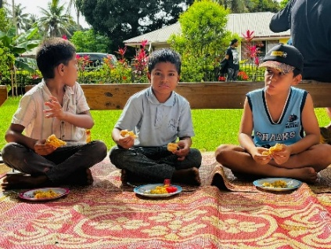

Figure 5: Devotions, Zumba & Food

The friends gather for devotion at the Payman residence every Saturday at 7:45am. Prayers are chanted and songs are sung with beauty and reverence. Following the devotional portion, Zumba sessions are run in a spirit of enthusiasm and joy before breakfast is shared amongst friends. The engagement across a wide age range adds to the vibrancy and community connection within this weekly space.
Dinner & Deepening
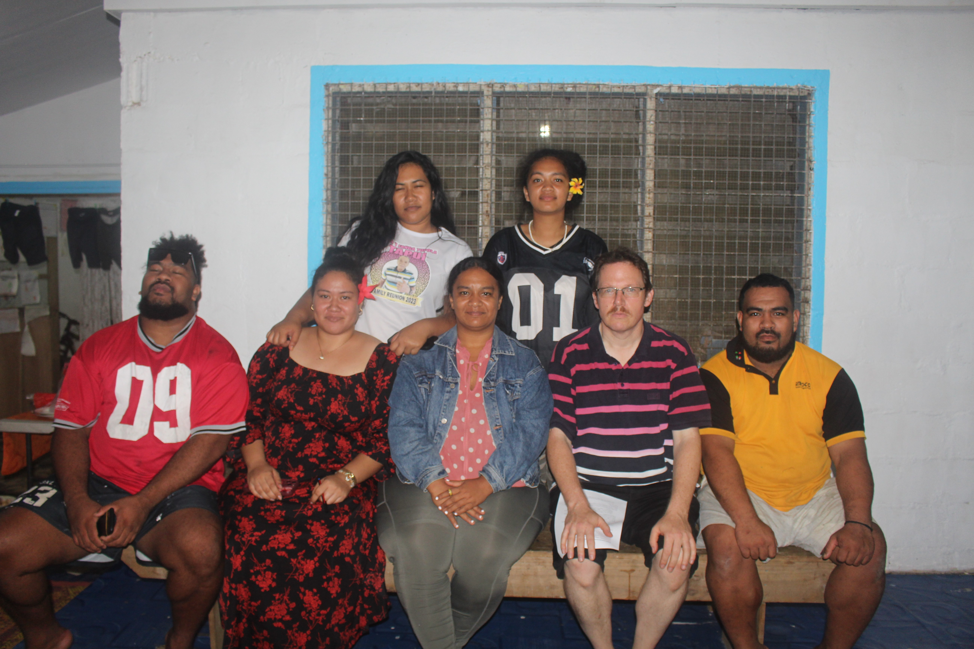

Figure 6: Youth Deepening

The youth continue to engage in weekly deepening, covering a wide range of spiritual topics, which include the purpose of trials, the sacred duty of voting,

conversations exploring marriage, equality of men and women, the Seven Valleys- and many others. These are hosted at the Kafalava Jnr residence on Mondays at 7pm, with the aim to deepen the knowledge of the youth and to build capacity to share on the core principles of the Faith so relevant to everyday life.

Youth night (Saturdays @ Mercy)
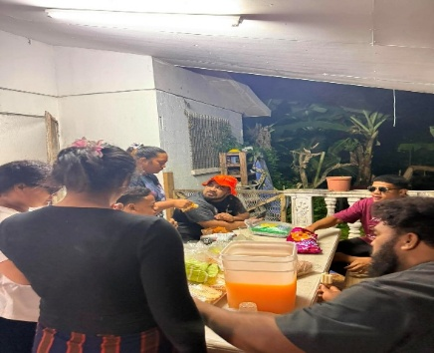

Figure 8: Youth Program

Every Saturday Tofoa’s Youth gathers at Mercy’s house for their normal Youth Group program. As of last week, the full round of hosting for each Youth member was completed. These spaces not only allow

each member of the Youth Group despite their minimum experience in the field of service to be able to host the Youth program and facilitate the Group. As this cycle closes the youth has reflected on their previous plan from start of last cycle: what they have achieved, reflection on what could’ve been done better and the plan moving forward to the next cycle and the first year of the second phase of the 9 Year Plan.

Junior Youth
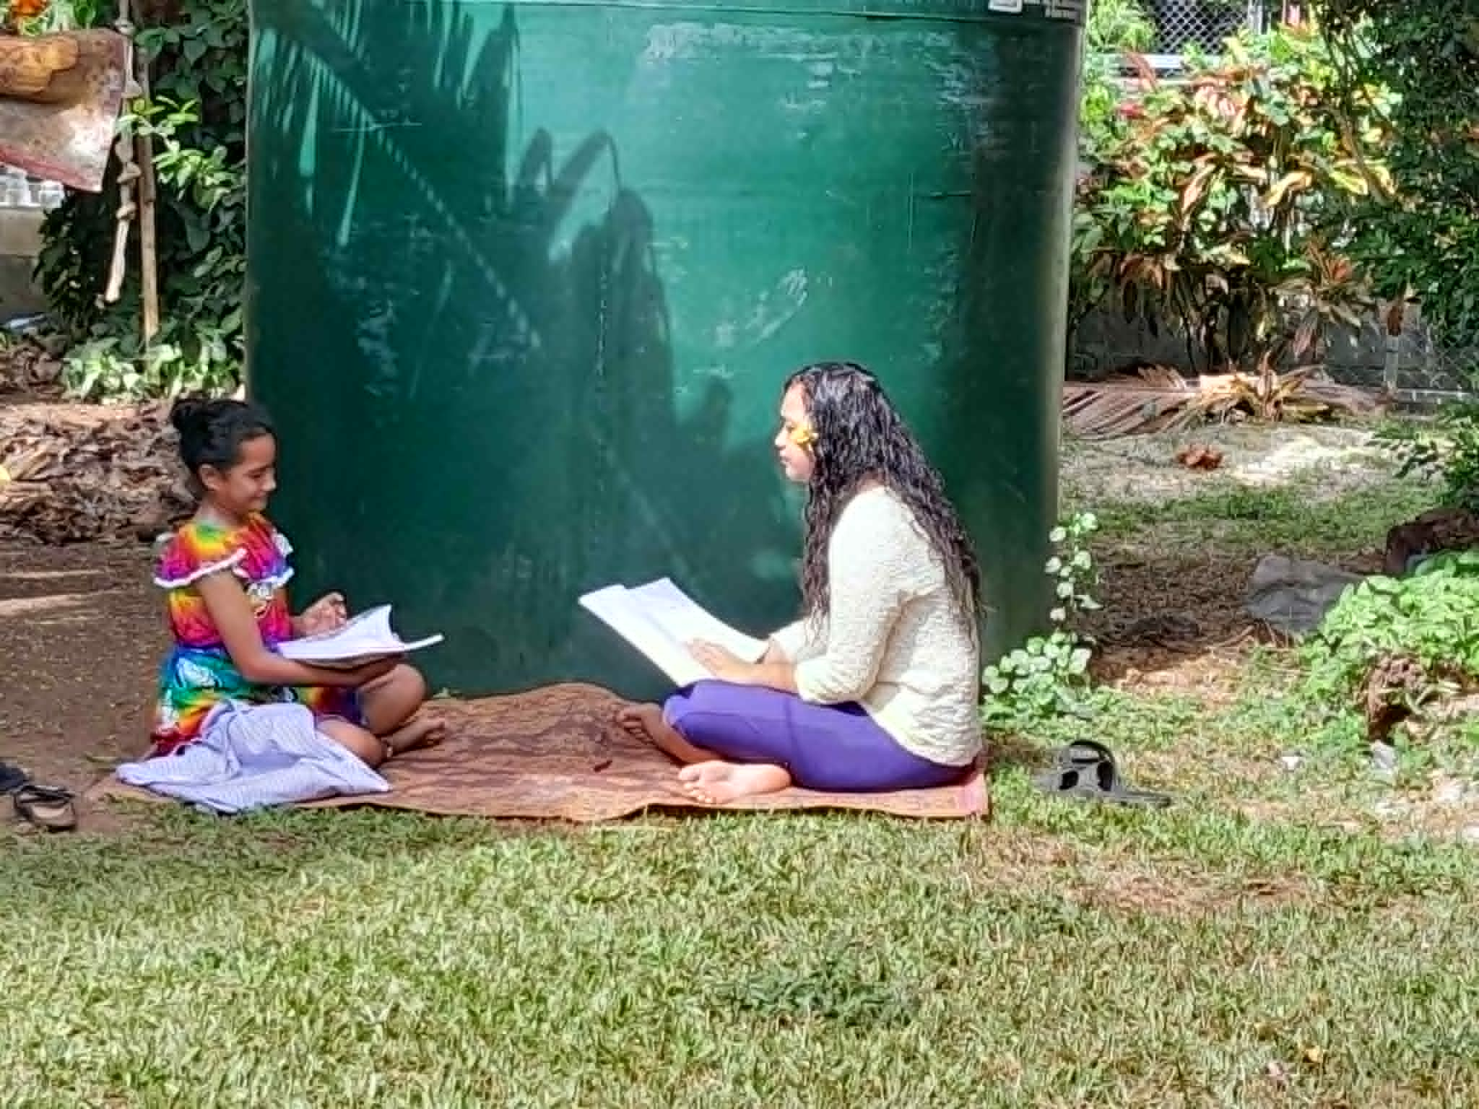

Figure 9: JY photo

The first Junior Youth group for BE183 was with only one member ‘Ana Keti.

Excitement fills her heart as she shares how the JY program brings hope to her heart. From not attending any JY program the past 1 year and a half this initiative to start was a gleam of hope to her JY journey. She shares how fast time is and how much being away from the program has impacted her that she is being influenced by the environment around her in a negative way and she wishes to complete her JY texts before she becomes a Youth. Not only will it help navigate her journey in life, but she will gain insights and knowledge for which will be useful when stepping in the field of service. Walking The Straight Path lesson 6 is the text they are studying with her Animator Ruby Kafalava.

Children’s Class

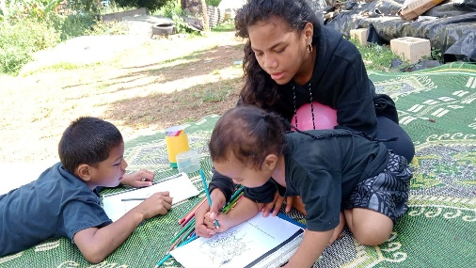

Figure 10: Children Class photo
After joining a Children Class Teachers Gatherings a JY (Saane)was interested in starting Grade 1. Saane, despite her little experience in being a children class teacher, is willing to run her own Grade 1. Being accompanied closely by the Children Class coordinator for cluster Vaheloto. Saane has so much confidence and is willingly excited to embark on this journey of being a Children Class Grade 1 teacher. At the same time, she is also running her JY texts with her Animator Ruby Kafalava.

Upcoming Events:

- Book 8 study circle
- Declaration of the Bab
- Feast of Nur
- Tutor’s Reflection Space

